Device Explorer for IoT Hub

* Getting Device Explorer
* Configure an IoT Hub connection
* Manage devices
* List registered devices
* Create device
* Update device
* Delete device
* Get device connection string or data
* Monitor device-to-cloud events
* Send cloud-to-device messages

Getting Device Explorer

https://github.com/Azure/azure-iot-sdks/releases

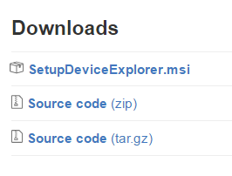

Configure an IoT Hub connection

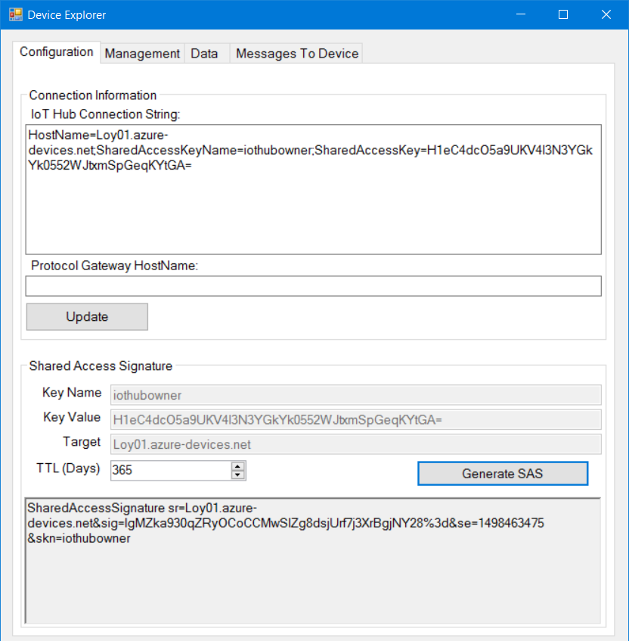

Manage devices

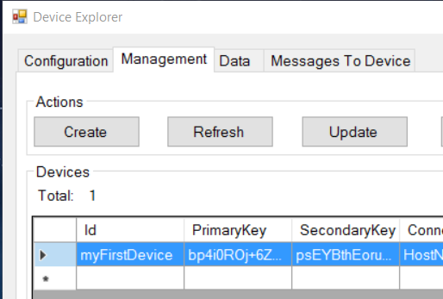

Create device (Add)

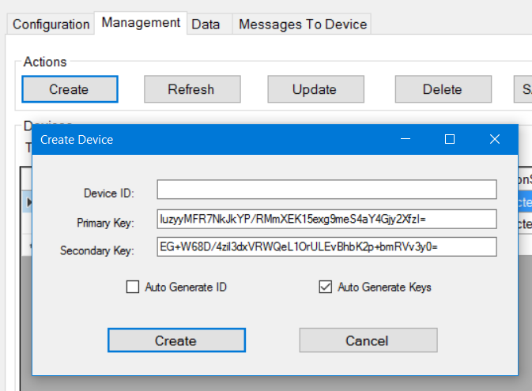

Update device

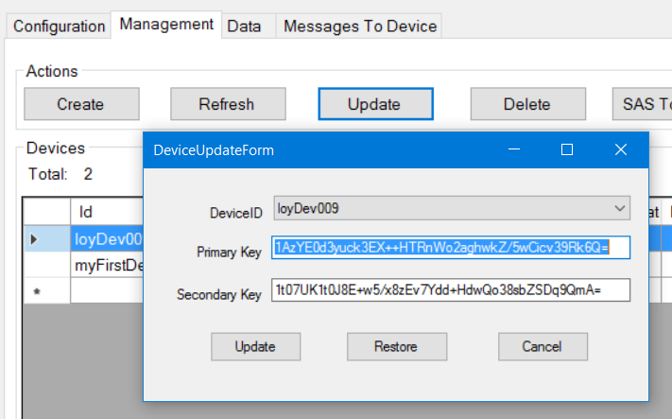

Delete device

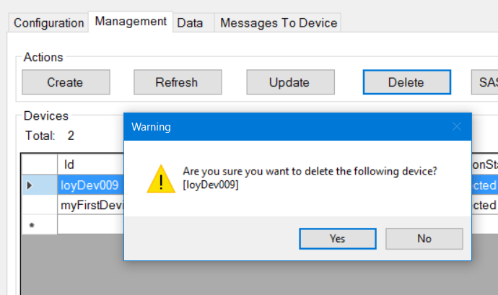

Get device connection string or data

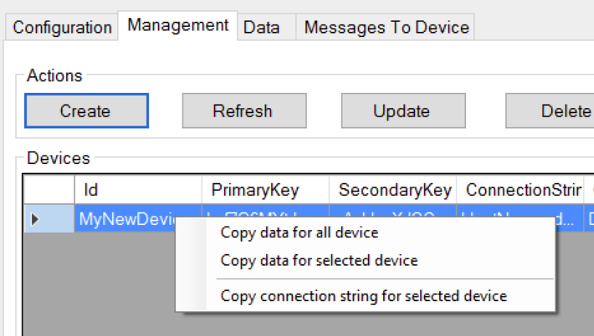

Monitor device-to-cloud events

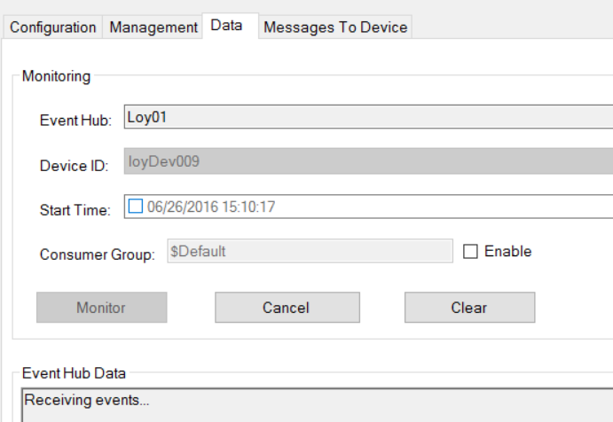

Send cloud-to-device messages

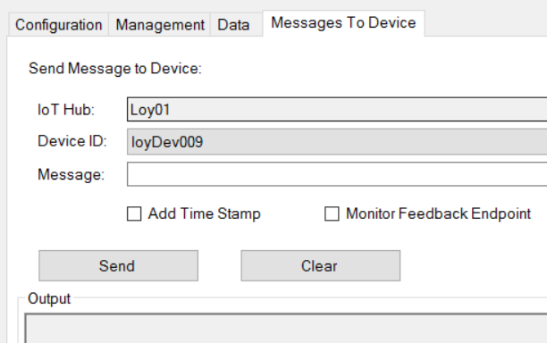

Creating Device Simulator

* AMQP
* JSON
* Create Device Simulator
* Send Device to Cloud Message
* Receive Cloud to Device Message

AMQP



* The Advanced Message Queuing Protocol (AMQP) is an open standard application layer protocol for message-oriented middleware.
* The defining features of AMQP are message orientation, queuing, routing (including point-to-point and publish-and-subscribe), reliability and security.

JSON



For embedded devices& low bandwidth, an another format is preferred JSON (JavaScript Object Notation)

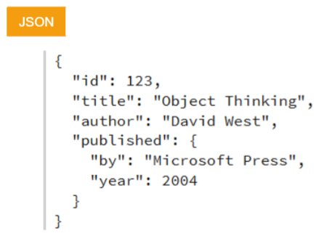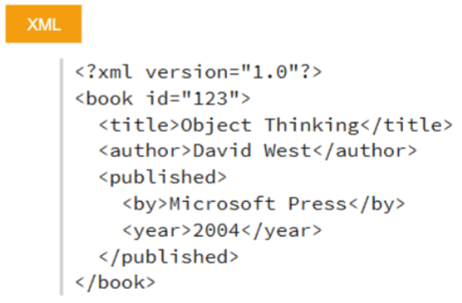

* JSON parser needs to be implemented to analyze server response
* JSON serializer to publish some data on the cloud

Create Device to Cloud Simulator

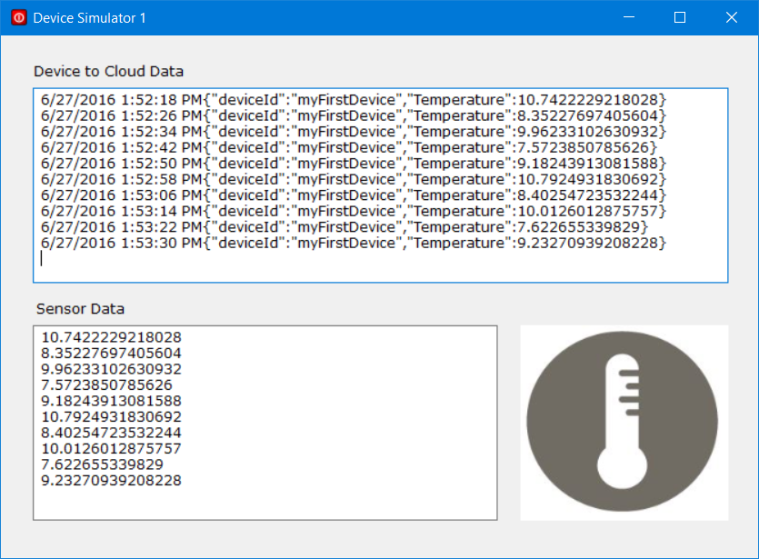

1. Create New Windows Forms Application “Sim01”

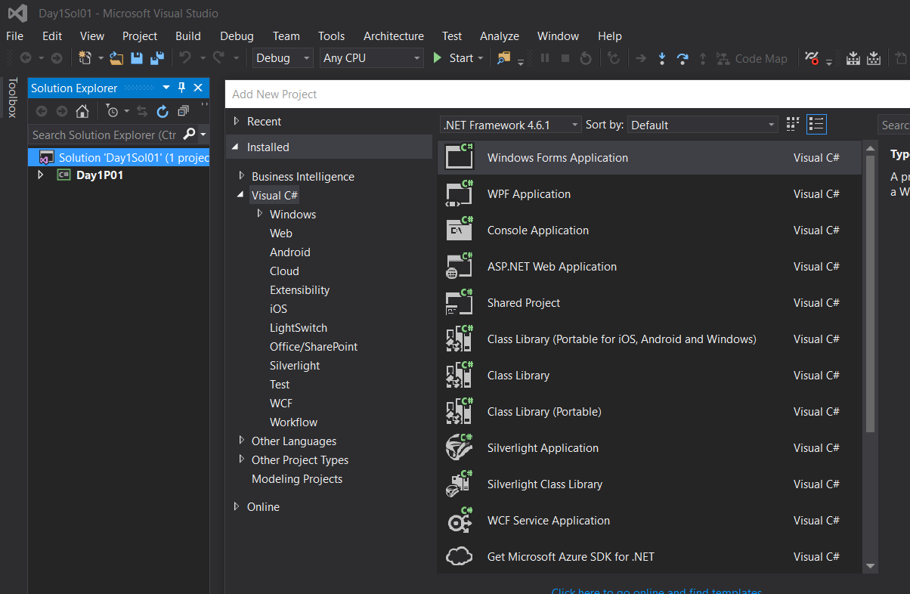

1. Add NuGet Package: Microsoft.Azure.Devices.Client

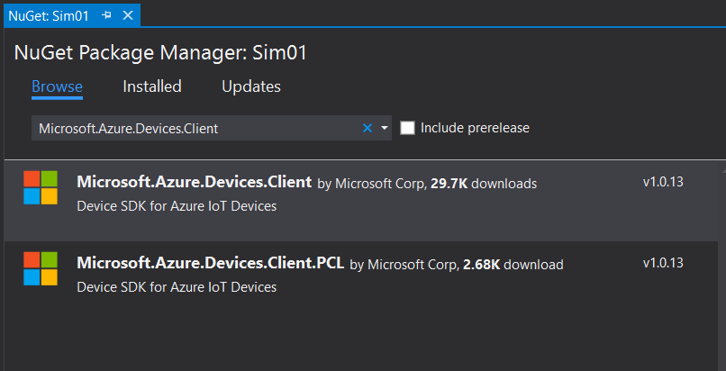

1. Add the following using statement at the top of the Form1.cs

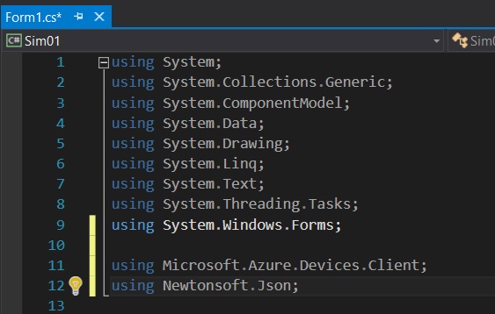

1. Add the following fields to the Form1 class.
   * Change iotHubUri
   * Change deviceKey

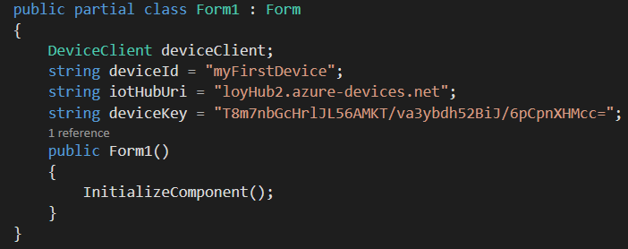

1. Your IoT Hub Home page

iotHubUri

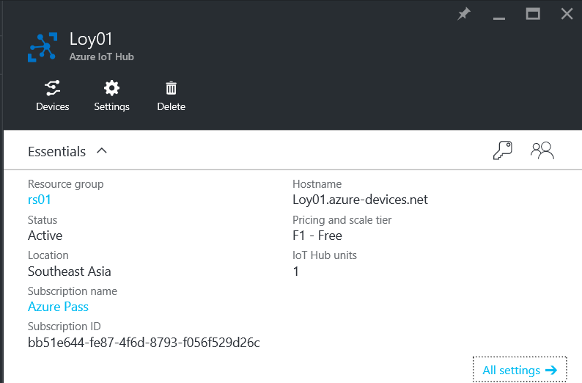

1. Azure IoT Hub/Devices/myFirstDevice/Device Details

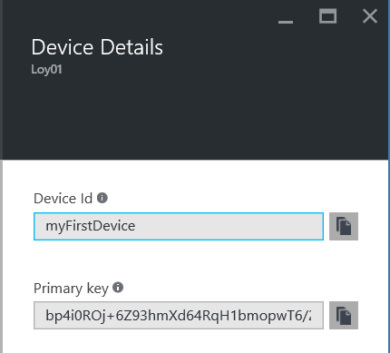

device key

1. Add 2 TextBox “textBoxD2C” and “textBoxSensorData”

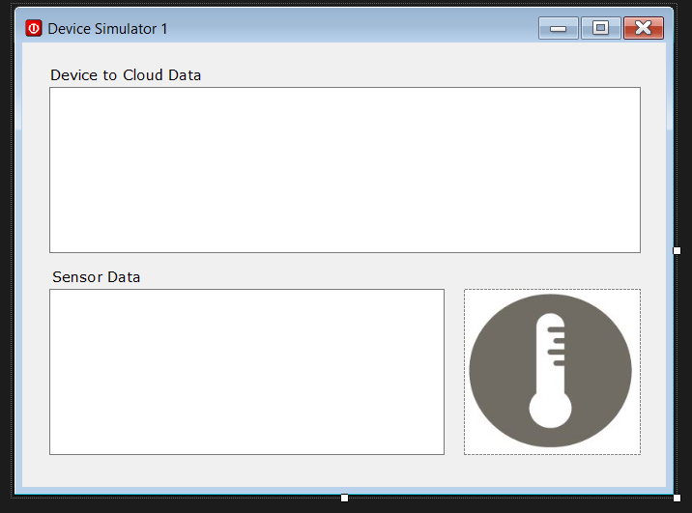\

1. Add below code to Form1 constructor method

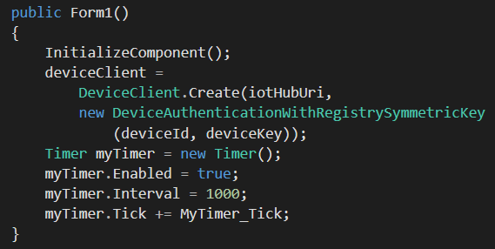

1. Add below code to Form1 Class

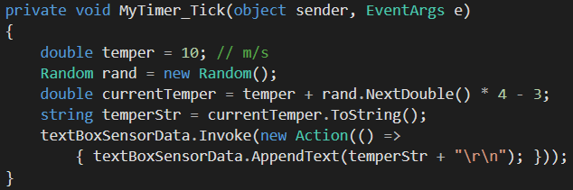

1. Test program. Observe the output.
2. Add below code to Form1 Class

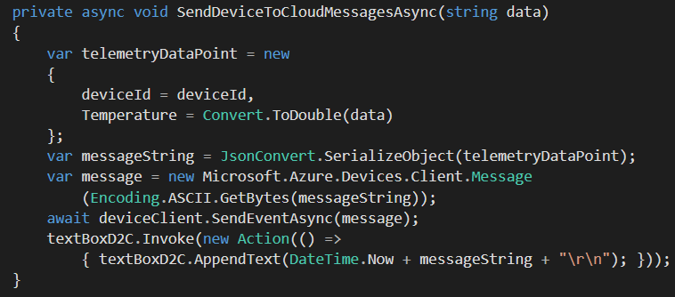

1. Modify MyTimer_Tick method

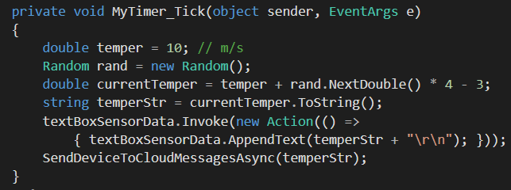

1. Use Device Explorer to inspect Device to Cloud Message

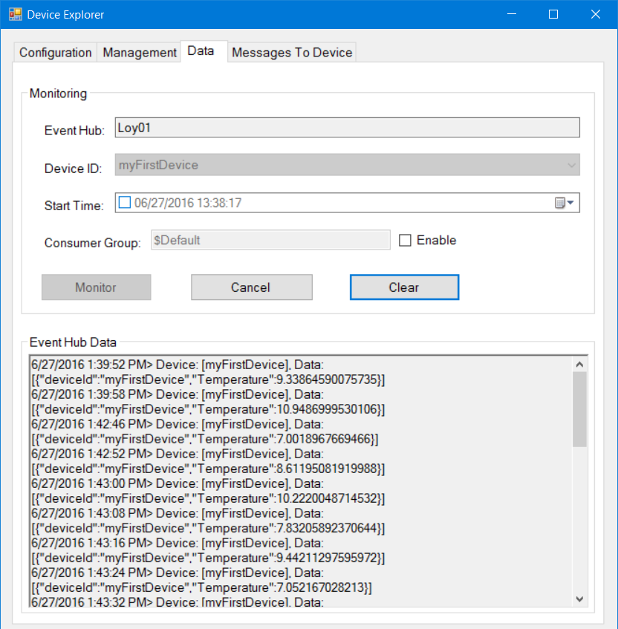

1. Open IoT Hub Home to inspect the Usage

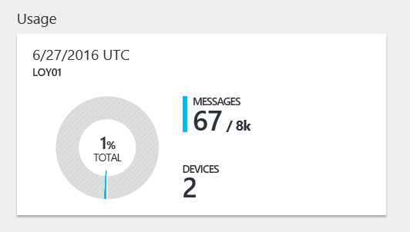

More on Create Simulated Device for Device to Cloud

* Get started with Azure IoT Hub for .NET

https://azure.microsoft.com/en-us/documentation/articles/iot-hub-csharp-csharp-getstarted/#create-a-simulated-device-app

* ADD A CUSTOM DEVICE TO THE AZURE IOT SUITE REMOTE MONITORING SOLUTION

http://rickrainey.com/2016/06/22/add-custom-device-azure-iot-suite-remote-monitoring-solution/

Receive message from Cloud

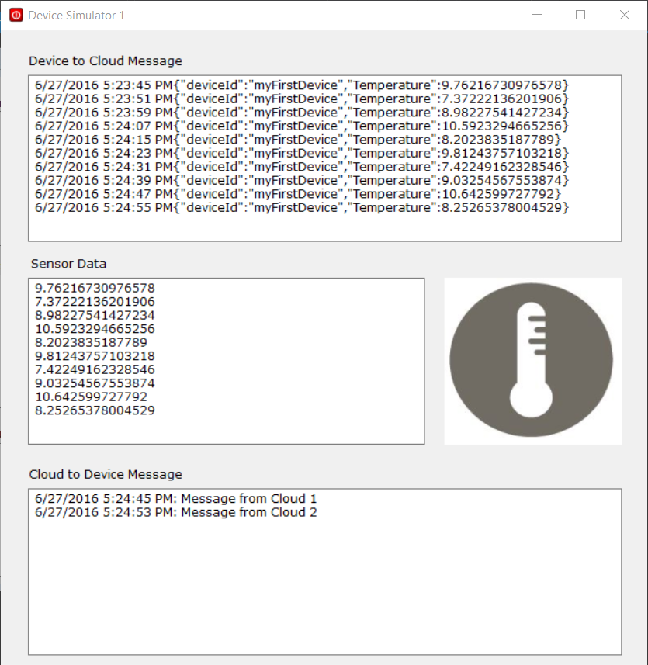

1. Add a TextBox to Form1. Name = “TextBoxC2D”

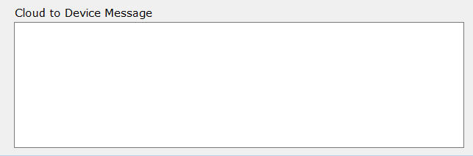

1. Add below method to Form1

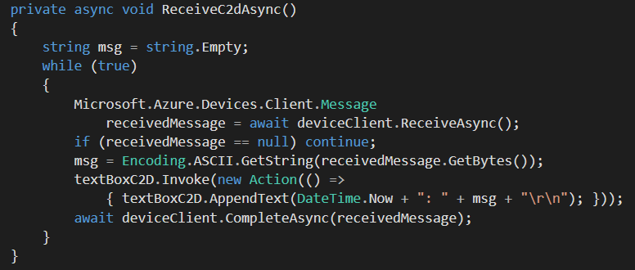

1. Modify Form1 Class Constructor

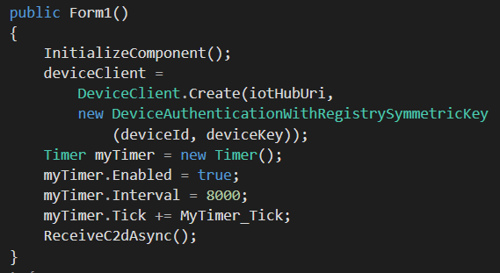

1. Test program: Use Device Explorer to send message

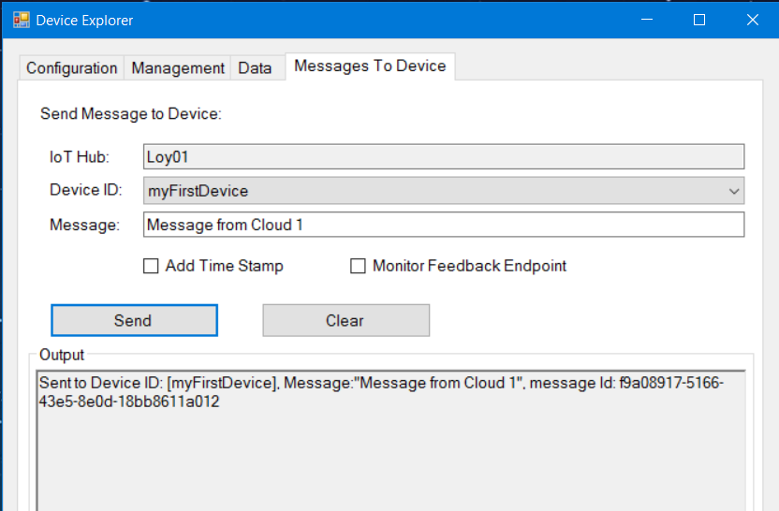

More on Cloud to Device Message

* Tutorial: How to send cloud-to-device messages with IoT Hub

https://azure.microsoft.com/en-us/documentation/articles/iot-hub-csharp-csharp-c2d/

* CONNECTING TO THE AZURE IOT HUB USING AN AMQP STACK

https://paolopatierno.wordpress.com/2015/10/24/connecting-to-the-azure-iot-hub-using-an-the-amqp-stack/